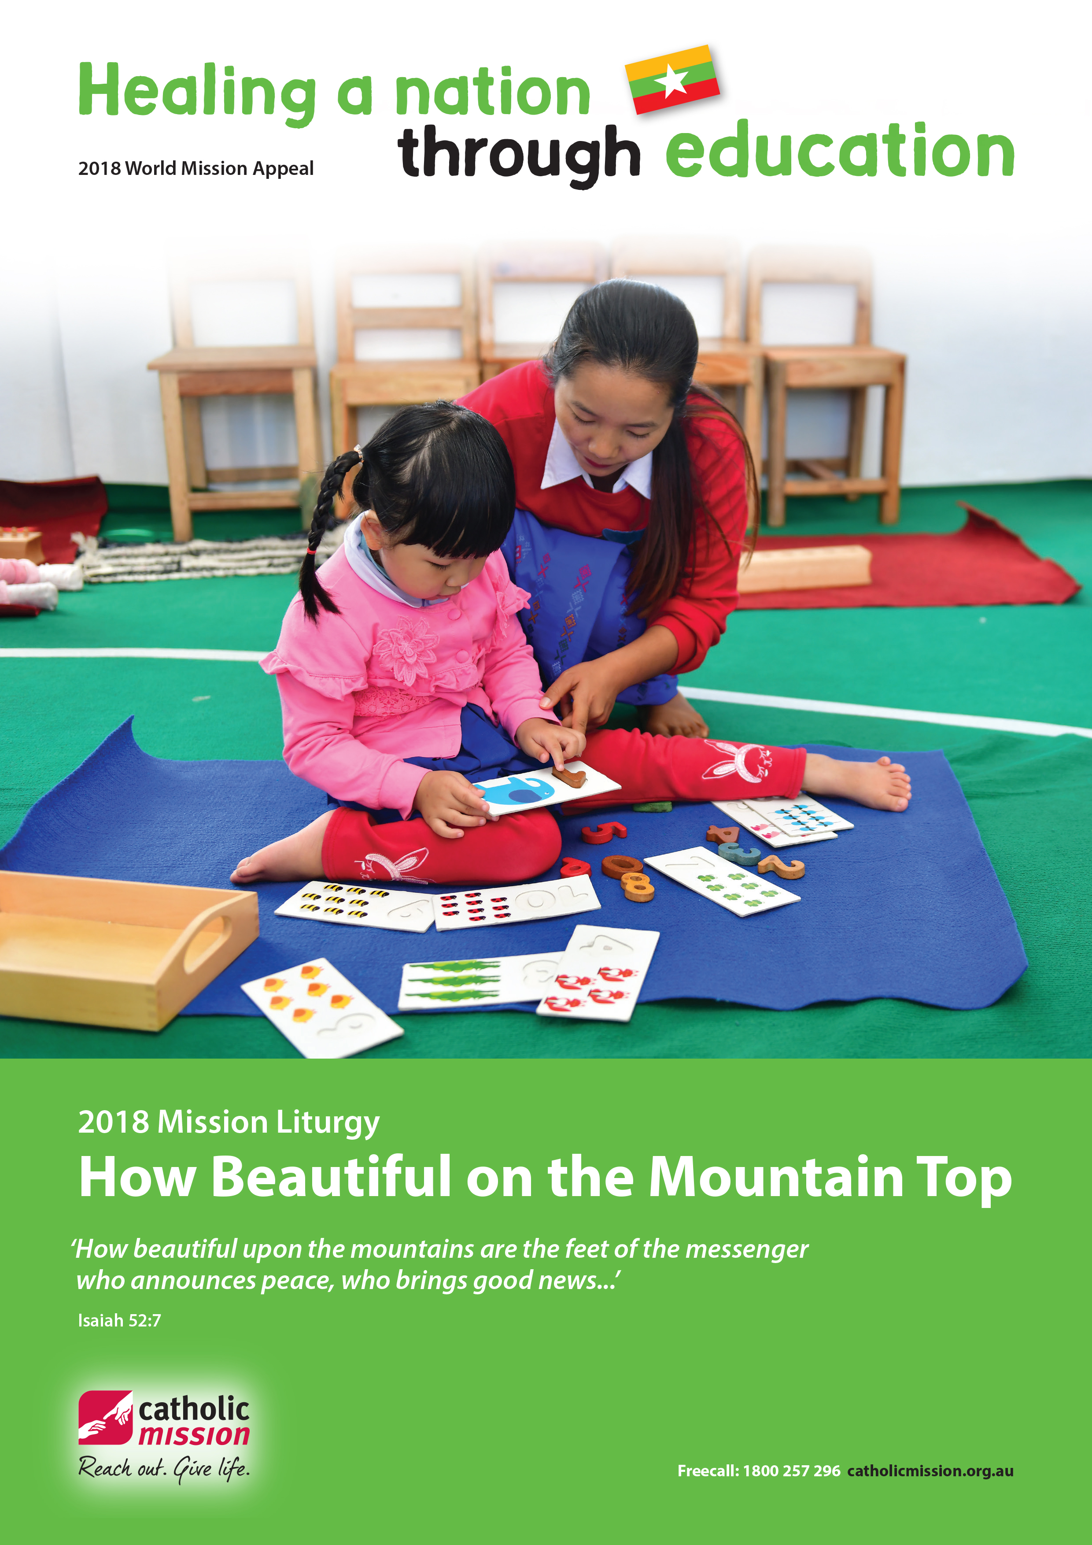



A Liturgy of the Word

You will need the following personnel:
Reader 1
Reader 2
Student with clapping sticks
Student for “The Voice of Isaiah”.
Student for “The Voice of Pope Francis”.
Eight students to place/replace symbols.
Narrator
A student to be Moses
A student to be the voice of God from the burning bush.
A group of six students to form a chorus.
A number of students to represent apostles.
A number of students to represent a crowd.
A student to be Jesus.
Reader/readers for five prayers of intercession.

You will need the following props:
clapping sticks
coloured fabric
cartons to create a focus space
a raised platform to represent a mountain top
a bush, festooned with orange, red and yellow streamers, anchored into a pot
a tropical plant
a photo of a red panda
a photo of the Dharma Wheel, a Buddhist symbol
a plastic firearm
a jug of dirty water
a glass bowl
a student exercise book with nothing written in it
a lighted candle
a first aid kit
a jug of clean water
a glass bowl filled with rice
a student exercise book filled with writing

Setting the space:
Centered is a raised platform covered with fabric to represent a mountaintop.
To the right is a bushy plant, anchored in a pot, and festooned with red, orange and yellow streamers. This represents the burning bush from Exodus.
To the left is a focus space, i.e., crates covered with fabric, on which can be placed symbols.

Acknowledgement of Country
Please remain seated.
[A student playing clapping sticks sounds them from the back of the assembly and continues to sound as they are processed towards the front. The clapping sticks fall silent and the person playing exits.]

Beginning Song
[An appropriate beginning song known by the assembly is sung here, or HOW BEAUTIFUL by Joe Wise is an excellent alternative. The sheet music for this song can be accessed at: ONE LICENSE:
https://onelicense.net.]
This is the ONE LICENSE title entry:
How Beautiful
Type: Words and Music; First Line: How beautiful on the mountaintop
© 1977, GIA Publications, Inc.
Contributors: Joe Wise
YouTube recording: https://www.youtube.com/watch?v=7dTeHJIqeyc

A Liturgy of the Word

continued...

Reader 1:
Welcome to this liturgy of the word
We gather today to celebrate our commitment to being prophets of God’s compassion and hope.

Reader 2:
We gather to be reminded of the freedom that a good education can bring to children who are fighting to break out of a cycle of poverty.

Reader 1:
We gather to give thanks for God’s saving activity through the work of Catholic Mission.

Reader 2:
We gather…
ALL: In the name of the Father, and of the Son and of the Holy Spirit. Amen

Reader 1:
In the book of Isaiah, the prophet says:
[A student comes forward to the raised platform and reads/speaks the following text.]

Voice of Isaiah:
‘How beautiful upon the mountains are the feet of the messenger who announces peace, who brings good news...’
[prophet exits]

Reader 2:
A great prophet of our own time is Pope Francis. He reminds us of that the provision of an education for those who cannot read and write is an act of mercy.
He says:
[A student comes forward to the raised platform and reads the following text.]

Voice of Pope Francis:
“The Church’s mission of evangelization has always been accompanied by teaching and the founding of schools, since education promotes the dignity of the person and provides for the full development of his or her God-given gifts. Illiteracy and lack of access to education are in fact a form of poverty and injustice.”

Reader 1:
Let us create our focus space.
Myanmar is a country of great natural beauty.
We place a tropical plant.
[A student comes forward with the plant, turns to face the assembly, raises the plant aloft, and then turns again to place the plant on the focus space]

Reader 2:
Myanmar is a country of wondrous wildlife.
We place a photo of a red panda.
[A student comes forward with the photo, turns to face the assembly, raises the photo aloft, and then turns again to place the photo on the focus space]

Reader 1:
Myanmar is a country with over 135 language groups. Buddhism is by far the dominant religion. We place a Buddhist symbol, the Dharma wheel.
[A student comes forward with the symbol, turns to face the assembly, raises the symbol aloft, and then turns again to place the symbol on the focus space]

Reader 2:
During the last 50 years, the people of Myanmar have suffered from fighting and violence.
We place a plastic firearm.

A Liturgy of the Word

continued...

[A student comes forward with the firearm, turns to face the assembly, raises the firearm aloft, and then turns again to place the firearm on the focus space]

Reader 1:
Because of fighting, cyclones and drought many children do not have access to clean water and sanitation.
We place a jug of dirty water.
[A student comes forward with the jug, turns to face the assembly, raises the jug aloft, and then turns again to place the jug on the focus space]

Reader 2:
In Myanmar one in three children is malnourished.
We place an empty bowl.
[A student comes forward with the bowl, turns to face the assembly, raises the bowl aloft, and then turns again to place the bowl on the focus space]

Reader 1:
In Myanmar half the children do not complete primary school. We place a child’s exercise book, empty of writing.
[A student comes forward with the book opened, turns to face the assembly, and raises the book aloft, then turns again to place the book on the focus space]

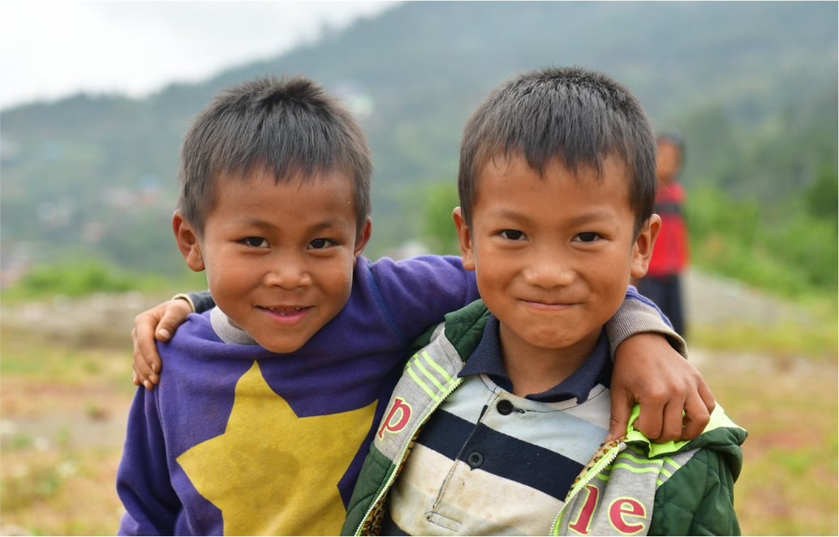

Reader 2:
Jesus says, “I have come to seek and save the lost.”
We place a lighted candle.
[A student comes forward with the candle, turns to face the assembly, raises the candle aloft, and then turns again to place the candle on the focus space]

Reader 1:
Let us reenact a scene from the Book of Exodus, “Moses before the burning bush”.
[A student, as Moses, comes forward and stands on the raised platform.
A student who is The Voice of God takes up position behind the burning bush, i.e., a leafy branch festooned with yellow, orange and red streamers]

Narrator:
This is Moses.
His name means, “drawn from the water”, because when he was a baby an Egyptian princess rescued him from the Nile River.
He was raised as a prince of Egypt… until he witnessed a Hebrew slave being beaten.
Moses struck the overseer.
He escaped from the land of Egypt and lived as a shepherd below the holy mountain called Sinai.
One day he saw a strange sight.
He saw a bush that was on fire.
But it was not burning up.
Moses went up the mountain.

Moses:
This is strange. Why isn’t the bush burning up?
I will go closer and see.
[Moses stands before the burning bush]

Narrator:
When the Lord saw that Moses was coming closer he called to him from the middle of the bush.

A Liturgy of the Word

continued...

Voice of God: Moses! Moses!
Moses: Yes. Here I am!
God: Do not come any closer. Take off your sandals, because you are standing on holy ground. I am the God of Abraham, Isaac and Jacob.
[Moses takes off his sandals and kneels]
Narrator: Moses covered his face, because he was afraid to look at God. Then the Lord said:
Voice of God: I have heard the cry of my people, and I see how the Egyptians are oppressing them. Now I am sending you to the king of Egypt so that you can lead my people out of his country.
Moses: I am nobody. How can I go to the king and bring the Israelites out of Egypt?
Voice of God: I will be with you, and when you bring the people out of Egypt, you will worship me on this mountain.
Now go and gather the elders of Israel together and tell them, “Yahweh, the God of your fathers has appeared to me, and he has said to me: I have visited you and seen all that the Egyptians are doing to you. And so I have resolved to bring you out of Egypt where you are oppressed… to a land where milk and honey flow.”
Narrator: The Word of the Lord
ALL: Thanks be to God
[An appropriate psalm or song can be sung here. Alternatively the song supplied, THIS PLACE ON WHICH WE STAND, can be sung]

This Place, On Which We Stand
This place on which we stand is holy ground
Take off your shoes. Take off your shoes.
This place on which we stand is holy ground
Take off your shoes. Take off your shoes.
All due reverence to the land beneath our feet
All due reverence to our God
To the wind song, the whispers of the breeze
All due reverence to our God
All due reverence to the colours of the dawn
All due reverence to our God
Gentle rainfall, mountain streams that tumble forth
All due reverence to our God
All due reverence to the person at your side
All due reverence to our God
To your true self, the ground of inner being
All due reverence to our God
© Richard Cootes 2016

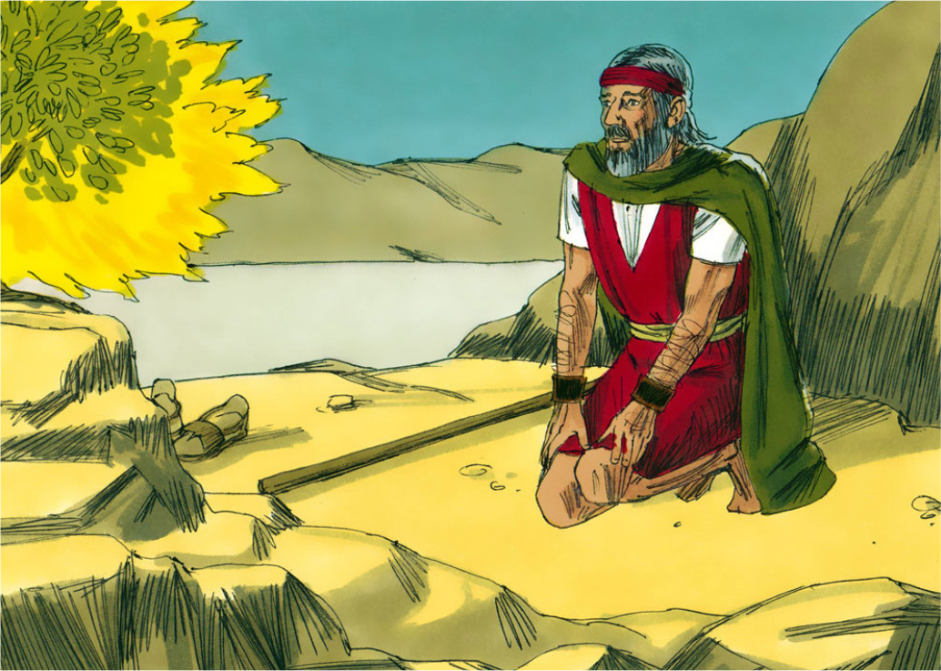

Gospel [Mt 5:1-12]

[Prior to the Gospel re-enactment, a stool is placed on the raised platform. A group of students representing the crowds sits in front of the platform. Another group of about half a dozen students stands as a separate group to the side to act as a chorus]

Reader 2
A reading from Holy Gospel according to Matthew.
Jesus saw the crowds and went up a hill, where he sat down. His disciples gathered around him, and he began to teach them.
[Jesus ascends the platform and sits on the stool.
Other students representing the apostles sit behind]

Chorus:
Blessed are the poor in spirit,

Jesus: [with hands raised]
for theirs is the kingdom of heaven.

Chorus:
Blessed are those who mourn,

Jesus:
for they shall be comforted.

Chorus:
Blessed are the meek,

Jesus:
for they shall inherit the earth.

Chorus:
Blessed are those who hunger and thirst for righteousness,

Jesus:
for they shall be satisfied.

Chorus:
Blessed are the merciful,

Jesus:
for they shall obtain mercy.

Chorus:
Blessed are the pure of heart

Jesus:
for they shall see God.

Chorus:
Blessed are the peacemakers,

Jesus:
for they shall be called children of God.

Chorus:
Blessed are they who are persecuted for the sake of righteousness,

Jesus:
for theirs is the kingdom of heaven.

Reader 2:
The Gospel of the Lord.
ALL: Praise to you Lord Jesus Christ

Reader 1:
In the mountainous Hakha Diocese, the church, with the help of donations from Catholic Mission, is building a new school. The school is called St John’s. Let us watch the video “Heal a Nation Through Education” from Catholic Mission to learn of the good work that is being done by the Church in Myanmar.
[Video inserted into PowerPoint is played.
At the end of the video a response can be sung. Either the song GOD IS ALL GOODNESS, supplied, or an appropriate song known to the assembly. Or, alternatively, a speaker who is competent to do so, may give a reflection.]

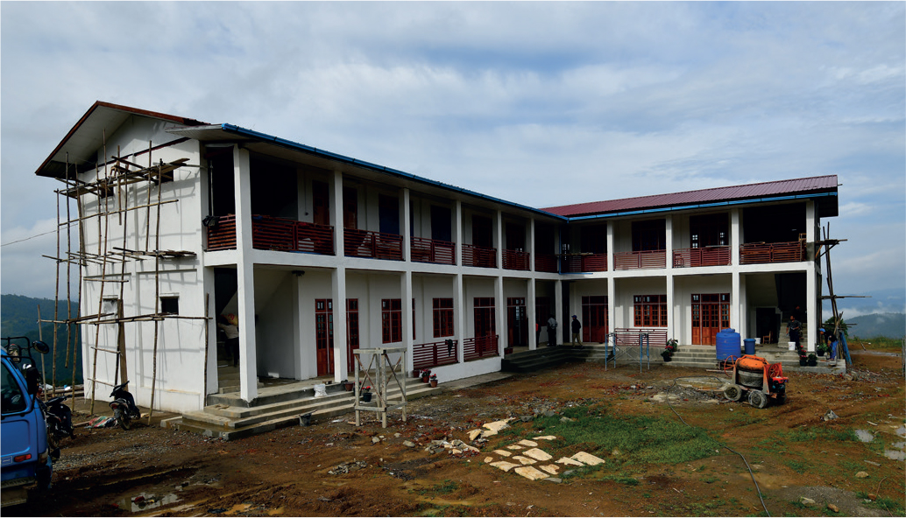

Gospel [Mt 5:1-12]

continued...

Prayers of intercession

God is All Goodness
God is all goodness, so let us be goodness.
Let us be the goodness of God in our world.
Where life is in shadow
Where life is diminished
Let us be the goodness of God in our world.
God is all mercy, so let us be mercy.
Let us be the mercy of God in our world.
Where life is in shadow
Where life is diminished
Let us be the mercy of God in our world.
We have been called to go forth you and I
The Spirit is calling. The Spirit is calling.
Proclaiming the Kingdom with our very lives.
The Spirit is calling. The Spirit is calling.
God is all presence, so let us be present.
Let us be present to God in our world.
Where life is in shadow
Where life is diminished
Let us be present to God in our world.
Let us be the presence of God in our world.
© Richard Cootes 2018

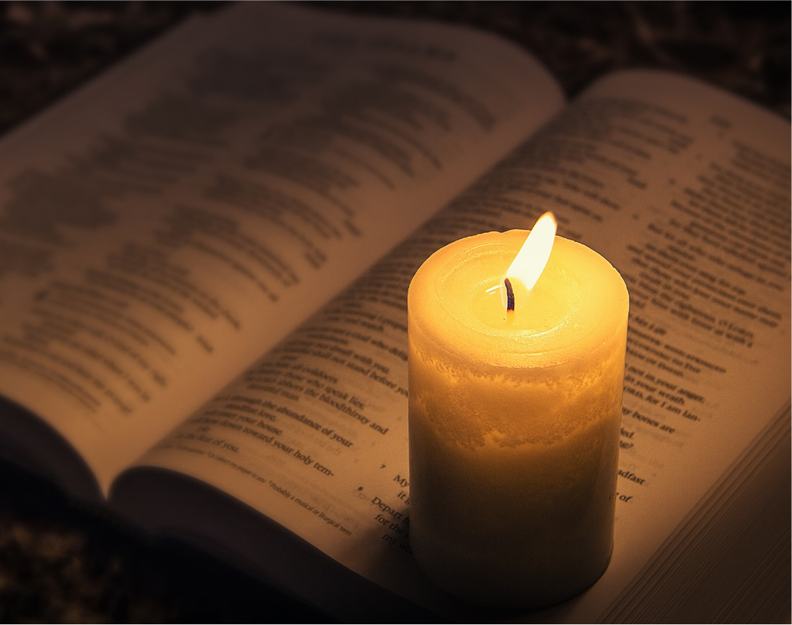

Reader 1
Jesus has told us to pray for all our needs, so now let us place before our heavenly Father our prayers.
1. “Blessed are the meek for they shall inherit the earth.”
Fill us with that generosity which will compel us to work for the betterment of all people, so that the gifts of creation may be more evenly distributed among the people of our earth. Lord hear us.
Response: Lord, hear our prayer.
2. “Blessed are the peacemakers.”
Bring peace to our troubled world, especially war-ridden nations. Help us all to build bridges that unite and not barriers that divide.
Lord, hear us.
Response: Lord, hear our prayer.
3. “Blessed are those who hunger and thirst for righteousness”
Give to all people, especially those afflicted by hunger, food that will enhance their dignity and nourish their souls and bodies. Lord of life, hear us.
Response: Lord, hear our prayer.
4. “Blessed are the poor in spirit”
Bless those who serve the poor, the sick and the needy in our world: remembering especially those who bring education to the children of Myanmar. Lord, hear us.
5. “Blessed are they who are persecuted for the sake of righteousness”
We pray for the prophets of God’s mercy and justice in Myanmar. Lord, hear us.
Response: Lord, hear us.

Prayers of intercession

continued...

Reader 1:
Lord grant that we may work with your Son, Jesus, to free the oppressed. We ask this through Christ our Lord.
ALL: AMEN

Reader 2:
In the light of our commitment to justice, let us place new symbols that represent our hope for the children of Myanmar. We replace the firearm on our focus space with a first aid kit.
[Two students come forward to accommodate this action. One takes away the firearm, the other raises the new symbol, with hands aloft for all to see, then places it on the focus space]

Reader 2:
We replace the dirty water with a jug of clean water.
[Two students come forward to accommodate this action. One takes away the dirty water the other raises a jug of clean water aloft, and then places it onto the focus space.]

Reader 2:
We replace the empty bowl with a bowl of rice.
[Two students come forward to accommodate this action. One takes away the empty bowl; the other raises a bowl of rice aloft, and then places it onto the focus space.]

Reader 2:
We replace the empty exercise book with an exercise book that has been filled with text.
[Two students come forward to accommodate this action. One takes away the exercise book; the other raises an opened exercise book filled with text aloft, and then places it onto the focus space. All students exit.]

Reader 1:
Let us say together the words that Jesus taught us. Our Father…
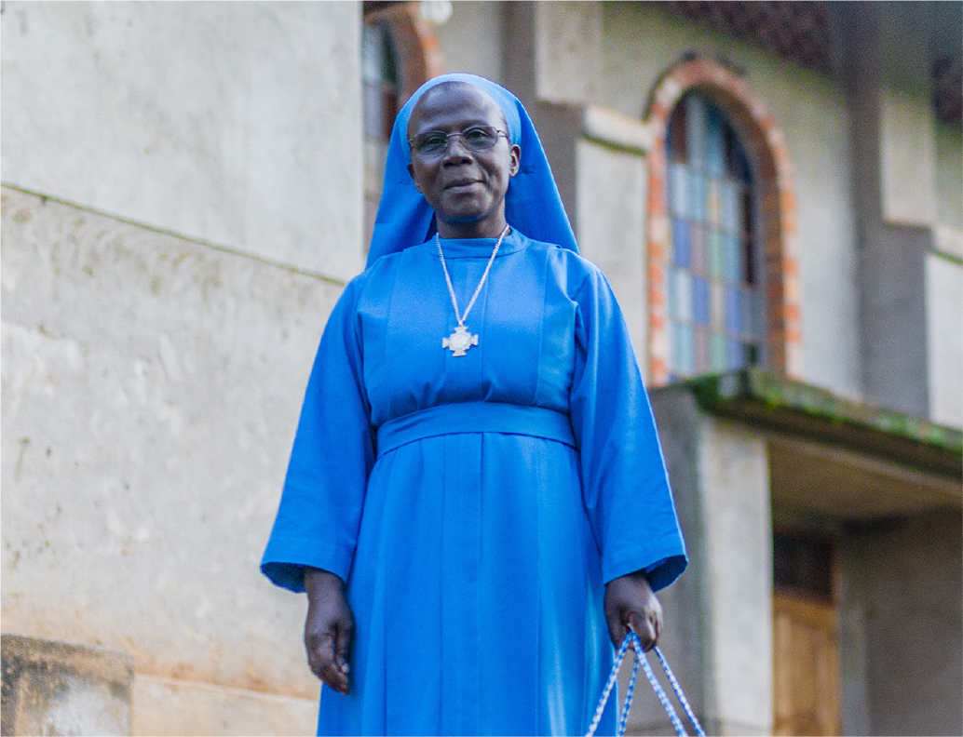

Reader 1:
Last year our focus for Catholic Mission was providing assistance for Sister Mary Goretti at the St Luke’s Health Centre in Uganda. Sister Mary came to Australia asking help from the students of our Catholic Schools to support her initiatives in providing for an ambulance, a children’s ward and other vital equipment necessary to look after new born children their mothers. Sr Mary expresses her thanks to us in this video.
[A short video inserted in the PowerPoint is played here]

Reader 2:
Thank you for participating in this liturgy. Let us go from this place as prophets of hope for our world.
We make this prayer through Christ our Lord.
ALL: AMEN

Final Song
[Conclude the liturgy with an appropriate song known to the assembly]

